**Quotation**

To: ***Autoedit.com***

Contact:  ***Ajit Mishra Job no:2021AE1630* Date: 29 August 2020**

|  |  |  |  |
| --- | --- | --- | --- |
| **SL** | ***Description*** | ***Rate*** | ***Amount*** |
|  | Project:  ***Lifebuoy Handwash***  Voice Artist (3 Person)  Studio Charge |  | 400$  200$ |
| **Total** | 600$ |
| **Advance** | - |
|  | ***In word: Six Hundred US Dollar Only*** | **Grand Total** | **600$** |

*N.B. Bill Should Be Paid to our Indian Bank account*

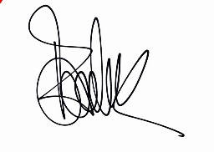

**Authorized Signature**